Pádraig Ó Conbhuí, 18/10/09
SFTP, Group 1 Labs
The Franck-Hertz Experiment for Mercury and Neon

Abstract:
This experiment was performed to record a Franck-Hertz curve for and estimate the first excitation energy of mercury and neon. Furthermore, the energy levels which contribute to the Franck-Hertz curve in neon and the relationship between the luminance bands in the neon tube and the characteristic Franck-Hertz curve of neon was also investigated.

Introduction and Theory:
This experiment was performed to record a Franck-Hertz curve for and estimate the first excitation energy of mercury and neon. Furthermore, the energy levels which contribute to the Franck-Hertz curve in neon and the relationship between the luminance bands in the neon tube and the characteristic Franck-Hertz curve of neon was also investigated.

According to quantum mechanics, an electron may absorb all or none of the energy it requires to jump to its next excitation state. This energy may be provided in the form of kinetic energy from another, travelling electron. Using this knowledge, we can plot a Franck-Hertz graph and determine the energies between these states. It is well known that the kinetic energy (E_{k}) of an electron is simply the negative of its charge (e) multiplied by the potential difference it has travelled through (V) and can be expressed by:
$$E_{k}=-eV$$

And so a simple discharge tube was used to record the current of electrons that have enough energy to surpass a retarding potential after traversing the tube. The drop in current should coincide with the number of electrons transferring their kinetic energy to the electrons in the mercury/neon atoms to reach their next excitation state. The circuit of which is as follows:

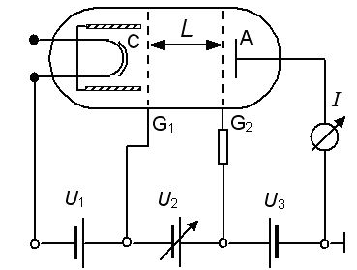

Legend:
C: Cathode
A: Annode

Experimental method:
For mercury, the circuit was set up similarly to the above, working on the same principle, except that the anode was cylindrical, encompassing the cathode and the whole tube was put in an oven and heated to 175°C, to vaporise the mercury.

