Cornu Method for Young’s Modulus and Poisson’s Ratio
Pádraig Ó Conbhuí 08531749 SFTP Wed

Abstract
This experiment was conducted to determine Poisson’s ratio and Young’s modulus for Perspex. The values found were 0.57±0.02 for Poisson’s Ratio and 5±2GPa for Young’s modulus. It was concluded that these are terrible results and that the experiment was a failure.

Method and Theory
When a beam is loaded as shown below, it is bent into an arc with a longitudinal radius of curvature $R_{1}$. This causes an extension of the surface above the beam and a compression below. This causes an internal bending moment, thus balancing the force of the load.
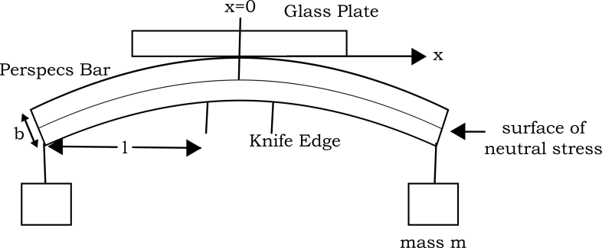

Young’s Modulus
The internal bending moment is given by $\frac{Y A{ k}^{2}}{R_{1}}$ , where $Y$ is Young’s modulus, $A$ is the cross sectional area of the beam, $k$ is the radius of gyration and $R_{1}$ is the radius of curvature. The radius of gyration is given by $k=\frac{b}{\sqrt{12}}$ for a bar of rectangular cross section. At equilibrium, the moment of the force and the internal bending moment are equal, giving:
$$mgl=\frac{Y A k^{2}}{R_{1}}$$
which rearranges to:
$$Y=\frac{mgl R_{1}}{A k^{2}}=\frac{12mgl R_{1}}{A b^{2}}$$

Poisson’s Ratio
Poisson’s ratio, $σ$, is defined as:
 | $$σ=\frac{\text{lateral strain}}{\text{longitudinal strain}}=\frac{R_{1}}{R_{2}}={\text{cot}}^{2}ϑ$$ | (1)

$R_{2}$ here is the radius of lateral curvature. When a body is stretched along its x-axis, it will tend to compress along its y-axis. Similarly when compressed along the x-axis, it will tend to stretch along its y-axis. Considering this phenomenon, it is easy to see that while the top of the bar is stretched along its x-axis on top and compressed along the same axis on the bottom, it will tend to compress along the y-axis on top and elongate on the bottom, giving rise to a lateral concave on the top of the bar, making it roughly pringular (pringle shaped). Poisson’s ratio measures the tendency of a body deform in the y direction when deformed in the x direction.

R₁, R₂ and d
$R_{1}$ and $R_{2}$ can be found using the cornu method, based on Newton’s rings. A glass plate is placed on top of the bent beam and an interference pattern can be seen forming from interference between light reflecting immediately off the lower surface glass and light that passes through the glass and reflects off the Perspex beam instead. This occurs because the light is (nearly) monochromatic. The fringes seen are contours of a constant distance, $d$.

Considering a longitudinal strain will cause a lateral strain as described, it is easy to see that this will cause the beam to assume the shape of a hyperbolic parabaloid, giving rise to elliptically based fringes. Similarly to the case of a spherical surface where fringes will be found at loci points of $d$ where $x^{2}+y^{2}=2\left(d-d_{0}\right)$ , in this case with a hyperbolic parabaloid we get
 | $$\frac{x^{2}}{R_{1}}-\frac{y^{2}}{R_{2}}=2(d-d_{0})$$ | (2)

since the bend in the y direction is somewhat inside-out. Here $d=d_{0}$ at $=y=0$ .

Since the fringes are also loci of points of constant $d$ , (2) implies that the fringes form two hyperbolae with common asymptotes at $x^{2}R_{2}=y^{2}R_{1} .$ The asymptotes are a pair of straight lines, each making an angle $ϑ$ with the x-axis, giving the second equality in (1).

So when $y=0$ , $x^{2}=2R_{1}(d-d_{0})$
And on a fringe $2d=nλ$ , $n∈N$

 | $$∴x^{2}=R_{1}(nλ-2d_{0})$$ | (3)

Experimental Method
$R_{1} \text{, }R_{2} , m , l , A$ and $b$ were to be measured. m was given on the weights used. The height, width and length of the bar were then measured before the bar was placed on the knife edges. $A$ was gotten by multiplying the height by the width and $b$ was the height.

Measuring R₁
First, the sodium lamp was turned on and allowed to warm up. The lamp shone horizontally on a glass plate tilted at 45° so the light would shine straight down on the glass plate on top of the Perspex. The weights were placed on the bar according to the diagram given. The bar was placed as centrally as possible between the two knife edges. The apparatus resembled the given diagram.

Efforts were made to ensure the travelling microscope travelled only along the x-axis, but this is a potential source for error.

First, the fringes were found. Next, the microscope was moved to the third fringe on the left, ensuring the microscope need only travel to the right. This was to avoid errors due to movement within the worm gear in the travelling section of the microscope. The microscope was moved to the right until it reached the second fringe to the left of the centre of the interference pattern and the reading on the vernier scale was taken down. The microscope was then moved to the right until it reached the second fringe on the right of the interference pattern. Again, the value on the vernier scale was taken down. The microscope was then moved to the third, fourth, fifth etc up to the tenth fringe on the right. The results were graphed and $R_{1}$ was thus deduced.

Measuring R₂
The exact same procedure was followed for measuring $R_{2}$ as was used for $R_{1}$ , except the Perspex rod and knife edges were rotated about 90°.

Measuring ϑ
$ϑ$ was measured by measuring the asymptotic pattern of the fringes with lens and a protractor.

Results, Analysis and Errors

R1

$$R_{1}=1.71±0.04\text{m}$$

R2

$$R_{2}=2.99±0.04\text{m}$$

ϑ
$$ϑ=0.96$$

Poisson’s Ratio
$$σ=\frac{R_{1}}{R_{2}}±\sqrt{{\left(\frac{δR_{1}}{R_{2}}\right)}^{2}+{\left(-\frac{R_{1}δR_{2}}{{R_{2}}^{2}}\right)}^{2}}=0.57±0.02$$
And
$$σ={\text{cot}}^{2}ϑ=0.48$$

Young’s Modulus
$$Y=\frac{12mgl R_{1}}{A b^{2}}$$

$$m=1 , g=9.8 , l=0.135±0.001m , A=\left(20±4\right)*{10}^{-5}$$
$$b^{2}=\left(3±1\right)*{10}^{-5} , R_{1}=1.71±0.04$$

Values and errors worked out on Mathematica…

$$Y=\left(5±2\right)*{10}^{9}\text{ kg} {\text{m}}^{\text{-1}} {\text{s}}^{\text{-2}}$$

Discussion and Conclusions
In theory, Poisson’s ratio may never exceed 0.5. Clearly a law of physics has been broken here. One source quotes Poison’s ratio for Perspex as 0.39. This experiment yielded 0.57±0.02, or 0.48 in the case of finding the angles between the asymptotes. The value found in this experiment should be discarded. It neither lies within the theoretical upper limit for Poisson’s ratio nor is it anywhere near other quoted values.

The value for Young’s modulus found here has a large error, but is within the allowed range. Sources quote the value around 2.5 GPa where this experiment yielded 5±2GPa, which is close enough.

There were many many potential sources for error in this experiment.
- It was impossible to get the bar perfectly in the middle of the knife edges.
- It was impossible to know that the reflector glass was at exactly 45° so it was impossible to know whether or not the light was shining directly down on the bar.
- The glass was rather scratched.
- The apparatus was very cumbersome, and results may have easily been skewed by having to work around the apparatus rather than with it.
- The weights may not have been completely free at all times. That is, they may have been resting on the apparatus without our knowledge at some time.
- The vernier scale may have been misread.

In conclusion, this experiment was a failure.

Resources
http://www.theplasticshop.co.uk/plastic_technical_data_sheets/working_with_perspex_manual.pdf
Young, H.D., Freedman, R.A., University Physics, 12th edition, Pearson Addison Wesley

