4068 Fortran Programming Coursework
6.5 Solitary waves from 2nd order time-dependent PDE

Name: Zora Wing Fong Law
Student ID: 00310913, SSTP
______________

Given the nonlinear PDE:
$\frac{∂A}{∂t}+\frac{∂}{∂x}\left(A^{2}−\frac{\sqrt{A}}{2}\frac{∂A}{∂x}\right)=0$ [1]
We decompose the equation into:
$\begin{aligned}\frac{∂A}{∂t}+\frac{∂Q}{∂t}=0 \\ Q(x,t)=A^{2}−\frac{\sqrt{A}}{2}\frac{∂A}{∂x}\end{aligned}$ [2]
with initial condition A(x,0) = A₀ = 1 × 10⁻⁵, 0 ≤ t ≤ 80 [3]
and boundary conditions Q(0,t) = Q₀ = 1, Q(100,t) = A₀², 0 ≤ x ≤ 100 [4]
______________

- Flow chart/Summary
- Given the nonlinear PDE [1], want to find its solutions.
- Simplify the problem by decomposing the 2nd order equation [1] into two 1st order equations involving A(x,t) and Q(x,t) [2].
- Approximate the derivatives by the finite difference method [5].
- Construct the lattice points (2-dimensional: x, t coordinates) such that they obey the initial condition [3] and the boundary conditions [4].
- By first finding the values of Q(x,t) in the 1st row (t = 0) and then the corresponding A(x,t), the calculation proceeds to obtain the values of Q(x,t) in the 2nd row (t = Δt) and thus A(x,t) and so on.

- Finite Difference Method
In order to calculate the derivatives, we approximate them using the following relations:
$\begin{aligned}\frac{∂A}{∂x}=\frac{A(x,t)−A(x−Δx,t)}{Δx} \\ \frac{∂A}{∂t}=\frac{A(x,t+Δt)−A(x,t)}{Δt} \\ \frac{∂Q}{∂x}=\frac{Q(x+Δx,t)−A(x,t)}{Δx}\end{aligned}$[5]
Hence, at a particular lattice point (x,t), Q(x,t) and A(x,t) are given by:
$\begin{aligned}Q(x,t)=A(x,t)^{2}−\frac{\sqrt{A(x,t)}}{2}\left(\frac{A(x,t)−A(x−Δx,t)}{Δx}\right) \\ A(x,t+Δt)=A(x,t)−Δt\left(\frac{Q(x+Δx,t)−Q(x,t)}{Δx}\right)\end{aligned}$ [6]

Note: Stability of solutions is only maintained if and only if the relationship of Δx and Δt satisfies the Courant condition. In our case, we choose Δx = 0.1, Δt = 0.005.

- Numerical Implementation
  - This program first sets up the initial conditions given by [3].
  - It then consists of a triple loop: the outer one (do j = 0…) keeps track of the time step (t), the inner two loop through lattice size step (x), i.e. across the entire row each time – one of them (do 20, i…) calculates all Q(x,t) values, follows by the other (do 40, i…) calculating all A(x,t) values
  - The “if…else…else” statement is needed to ensure the end points satisfying the boundary conditions [4].
  - The evaluations of Q(x,t) and A(x,t) are given by [6].
  - For every 100th time iteration, the values of i, j, x, t, A(x,t) and Q(x,t) are printed into the output file. The final solution is the last A(x,t) value.
  - E(x,t) are the exact solutions, given by [7].

- Results & Analysis
The solutions to the equation are solitary waves.
Fig. 1
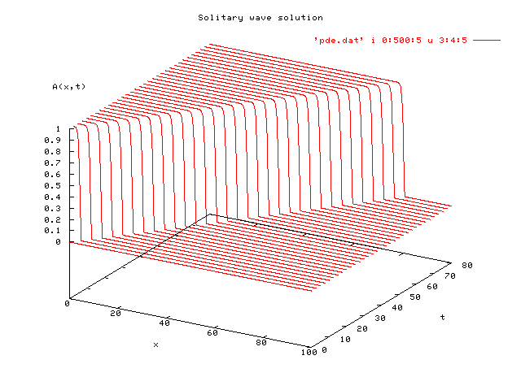 Fig. 2

The exact solution with A(x,0) = 0 is given by:
$A(x,t)=\left\{\begin{matrix}v{\text{tanh}}^{2}(\sqrt{v}(x−\text{vt})) & x≤\text{vt} \\ 0 & x≥\text{vt}\end{matrix}\right.$ [7]
Plotting alongside with the exact solutions [7], Fig. 3 and Fig. 4 are generated:
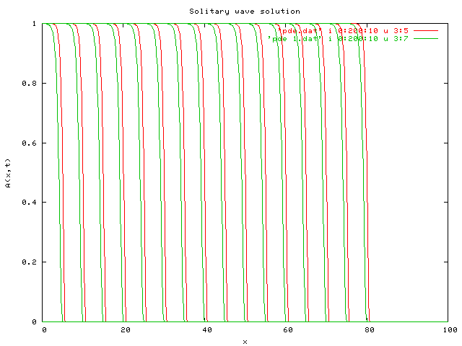 Fig. 3
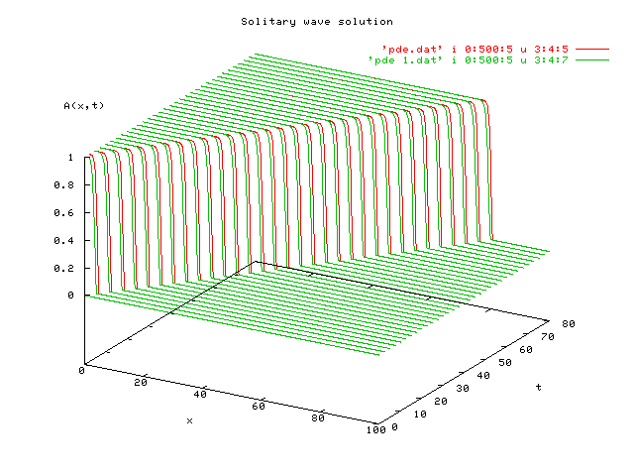 Fig. 4
(green – exact solutions; red – numerical results)
We notice there is a slight shift between our calculated values and the exact solutions.

The velocity v is evaluated by measuring the distance travelled divided by the particular time interval, referring to Fig. 2, t = 80, x = 80, thus v = 1 (Q₀ = 1 case).
We can demonstrate the relationship between v and Q₀ using the following tabulated results:

Q₀ | x | t | |A| | v
1.0 | 80 | 80 | 1.0 | 1.0
2.0 | 70 | 50 | ~1.5 | ~1.5
3.0 | 90 | 50 | ~1.8 | ~1.8
4.0 | 90 | 45 | 2.0 | 2.0

Clearly, |A| ∝ v. Infact Q₀ ∝ v², i.e. v ∝ Q₀^{1/2}.
Attachment 1: program ex5.f
program ex5
c a program to solve the nonlinear PDE using finite difference
c (dA/dt) + (d/dx)[A^2 - (sqrt(A)/2)*(dA/dx)] = 0, A=A(x,t)
c 2nd order eqn -> two 1st oder eqns:
c (dA/dt) + (dQ/dx)=0
c Q = A^2 - (sqrt(A)/2)*(dA/dx), Q=Q(x,t)
c finite difference method:
c (dA/dx) = [A(x,t) - A(x-dx,t)]/dx
c (dA/dt) = [A(x,t+dt) - A(x,t)]/dt
c (dQ/dx) = [Q(x+dx,t) - Q(x,t)]/dx
c exact solution: A(x,t) = vtanh^2(sqrt(v)*(x-vt)) x<=vt
c A(x,t) = 0 x>vt

implicit none

real a0, q0
integer max_size, max_time, sizestep, timestep

parameter (a0=1.E-6, q0=1.0)
parameter (max_size=100,max_time=80,sizestep=1000,timestep=16000)

real a(0:sizestep,0:timestep), q(0:sizestep,0:timestep)
real e(0:sizestep,0:timestep) !exact solution
real dt, dx, t, x, v
integer i, j

dt = dble(max_time)/dble(timestep)
dx = dble(max_size)/dble(sizestep)
x=0.
t=0.
v = 1. !q0=1

do i = 0, sizestep !initial condition a(x,0)=a0
a(i,0) = a0
enddo

open (1, file='pde_1.dat')
c write (1,*) 'i, j, x, t, a(i,j), q(i,j), e(i,j)'
do j = 0, timestep
t = dble(j)*dt

do 20, i = 0, sizestep !find first q(i,j)
if (i.eq.0) then !boundary conditions q(0,t)=q0
q(i,j) = q0
else if (i.eq.sizestep) then !q(L,t)=a0^2
q(i,j) = a0**2.
else
q(i,j) = a(i,j)**2 - (a(i,j)**0.5)*(a(i,j)-a(i-1,j))/(2.*dx)
endif
20 continue !i1

do 40, i = 0, sizestep !proceed to find a(i,j)
x = dble(i)*dx
if (i.eq.sizestep) then
a(i,j+1) = a(i,j)
else
a(i,j+1) = a(i,j) - (dt/dx)*(q(i+1,j) - q(i,j))
endif

if (x.gt.v*t) then !evaluation of A(x,t) using the exact solution
e(i,j) = 0
else
e(i,j) = v*(tanh(sqrt(v)*(x-(v*t)))**2)
endif

if (mod(j,100).eq.0) write (1,*) i, j, x, t, a(i,j),
& q(i,j), e(i,j)
40 continue !i2
if (mod(j,100).eq.0) write (1,*)
if (mod(j,100).eq.0) write (1,*)
enddo !j

stop
end

Attachment 2: Variations of v against Q₀
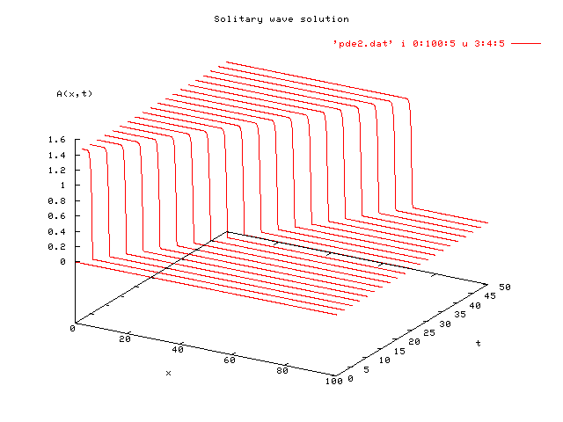 Q₀ = 2 case Fig. 5
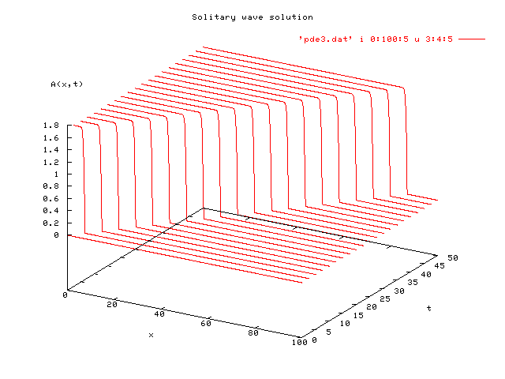 Q₀ = 3 case Fig. 6
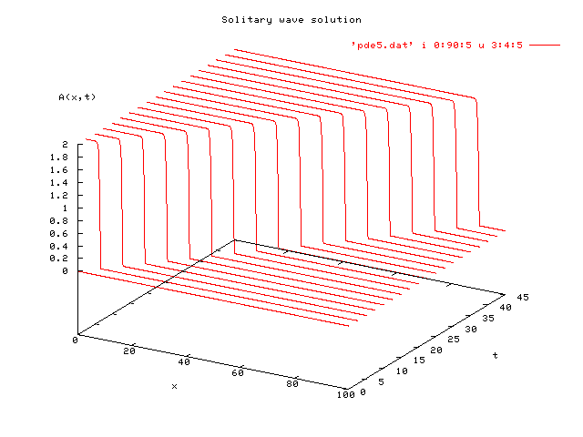 Q₀ = 4 case Fig. 7

