The Advantages And Disadvantages Of Anaerobic Digestion As A Renewable Energy Source
.

Peter Stuart

Loughborough University

Loughborough, Leics LE11 3TU

Abstract: The benefits and drawbacks of anaerobic digestion as a waste stabilisation process and renewable energy source are explored. The process is found to have a broad spectrum of benefits but its inherent complexities and high capital cost continue to inhibit uptake.

1. INTRODUCTION

Anaerobic digestion is a process by which environmentally hazardous organic wastes from municipal, agricultural and industrial sources may be stabilised. The treatment has many side benefits, most notably the production of methane-rich biogas which can be used to generate electricity and heat.

Anaerobic digestion is performed by a consortium of micro-organisms. In the absence of oxygen the anaerobic bacteria break down organic matter producing methane and carbon dioxide. Several other methods of dealing with organic wastes exist, including aerobic digestion, direct application to land and combustion. These methods either utilize the available biomass as a fertiliser or a fuel, but not both as is the case with anaerobic digestion. Unfortunately the use of anaerobic digestion is not as widespread as the other options.

2. ADVANTAGES

The primary use of anaerobic digestion is waste stabilisation. There are however many ancillary benefits which must be fully exploited in order to ensure the economic viability of the process.

2.1 Available Resources
The starting material for anaerobic digestion is normally some form of waste unless biomass has been produced specifically for use as a feedstock. A vast amount of waste is available for processing from a variety of sources:
- Domestic / Municipal Waste: The UK produces nearly 30 million tonnes of domestic waste each year. 60% of household waste is biodegradable of which 25% is kitchen waste and other organics and 30-35% is paper [1].
- Sewage Waste: The UK produces an estimated one and a half million tonnes of sludge per year by processing sewage aerobically [2]. Anaerobic digestion is an alternative process which creates far less sludge.
- Agricultural Waste: Every year in the UK about 150 million wet tonnes of livestock slurry (pig and cattle) and 3.4 million wet tonnes of used poultry litter and excreta are produced [3].
- Food production residues: It is estimated in excess of one million tonnes of food production residues suitable for anaerobic digestion are produced annually [3].
Anaerobic digestion thus has the advantage of utilizing materials which are widely available. Dealing with waste also has the additional advantage that the material already has a negative value of approximately –£0.10 a tonne.

2.2 Useful Products
Anaerobic digestion is primarily of interest to renewable energy technologists because it produces methane which when combusted can be used to produce heat and power.

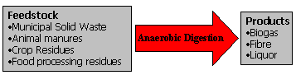

Figure 1. Anaerobic digestion: Waste to useful products

Biogas is not the only useful product, digestion residues are also very valuable organic alternatives to chemical fertilisers. The economic viability of anaerobic digestion relies of the full utilization of all of its products.

2.2.1 Gas Production
An obvious benefit of anaerobic digestion is the production of methane rich biogas which offers a renewable alternative to the consumption of fossil fuels. During digestion 30-60% of the digestible solids are converted into biogas. The overall process is described as carbon neutral: after digestion and combustion the total release of carbon dioxide to atmosphere is equal to that which was absorbed to produce the biomass. The biogas produced by anaerobic digestion does not consist entirely of methane as it also contains carbon dioxide and smaller amount of other gases.

Constituent Gas | Percentage Composition
Methane | 60-80%
Carbon Dioxide | 20-40%
Nitrogen | 0-5%
Hydrogen Sulphide | 0-3%
Volatile compounds | Traces

Table 1. Composition of Biogas [4]

One m³of biogas with a methane content of 70% (2MJ/m³) is equivalent to [4]:
- 0.60 litres of petrol
- 0.58 litres of alcohol
- 0.90 kg of charcoal
- 1.70 kWh of electricity ( assuming a conversion efficiency of 30%)
- 2.50 kWh of heat only (assuming a conversion efficiency of 70%)
- 1.70 kWh of electricity and 2.50 kWh of heat in a CHP system.

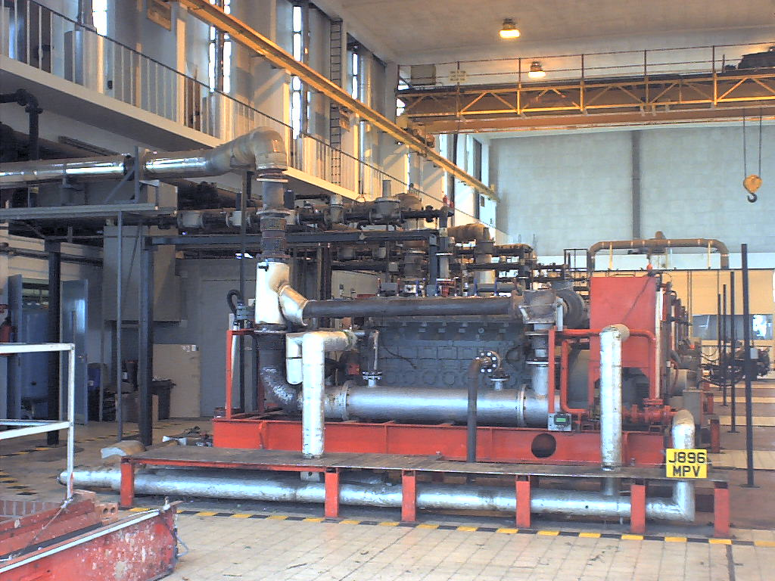

Figure 2. Biogas powered electrical generator

The composition of the gas may be estimated with the following formula [5].

$$\begin{aligned}C_{n}H_{a}O_{b_{(\text{aq})}}+(n−\frac{b}{2}−\frac{a}{4})H_{2}O\vec{} \\ (\frac{n}{2}+\frac{b}{4}−\frac{a}{8}){\text{CH}}_{4_{(g)}}+(\frac{n}{2}+\frac{a}{8}−\frac{b}{4}){\text{CO}}_{2_{(g)}}\end{aligned}$$ | (1)

Hence if the small amount of substrate that is used to produce new cells and to provide cellular maintenance energy is ignored, the gross stoichiometry of the anaerobic digestion of glucose (n=6, a=12, b=6) can be represented by:

$$C_{6}H_{\text{12}}O_{6_{(\text{aq})}}\vec{}3{\text{CH}}_{4_{(g)}}+3{\text{CO}}_{2_{(g)}}$$ | (2)

The free energy change of the this process is –418kJ so the thermodynamic driving-force is strong. The enthalpy change however is only –131kJ, representing a small exothermic loss [6]. We can also examine the follow two very important ratios:

$$\frac{\text{Mass of methane produced}}{\text{Mass of glucose converted}}≈\text{27}\text{\%}$$ | (3)

$$\frac{\text{Energy content of methane}}{\text{Energy content of glucose converted}}≈\text{95}\text{\%}$$ | (4)

Eqns. 3 and 4 show that nearly all the energy from the glucose is transferred to a simple gaseous hydrocarbon where is resides at a higher mass density. The methane produced can easily be separated from the aqueous system, and if so desired from the co-product CO₂. Anaerobic digestion therefore offers the opportunity to efficiently produce a premium hydrocarbon fuel from waste materials of a potentially negative value.

Up to one third of the biogas is required to sustain the reactor. The remaining two thirds can be used to generate heat, electricity or both. Combined heat and power (CHP) production is by far the most efficient use of the available energy. If such a system is put in place the whole digester heat requirement is normally recovered from the engine and exhaust gas. Heat and electricity can be used to meet the energy requirements of the facilities at which they are generated (farms, sewage treatment plants etc.) or can be sold to external consumers.

Figure 4. Growth of biogas plants in Germany [8]

Fig. 4 shows the growth in biogas plants in Germany from 1992-1998. The plants have an average in-stalled electricity capacity of 60 kWh, uptake has been aided by favourable legislation [7].

2.1.2 Fertiliser Production
The organic fertilisers produced by anaerobic digestion offer a considerably cheaper alternative to the chemical fertilisers and agrochemicals used in agriculture. The use of artificial fertilisers has a considerable impact on overall running costs [8].

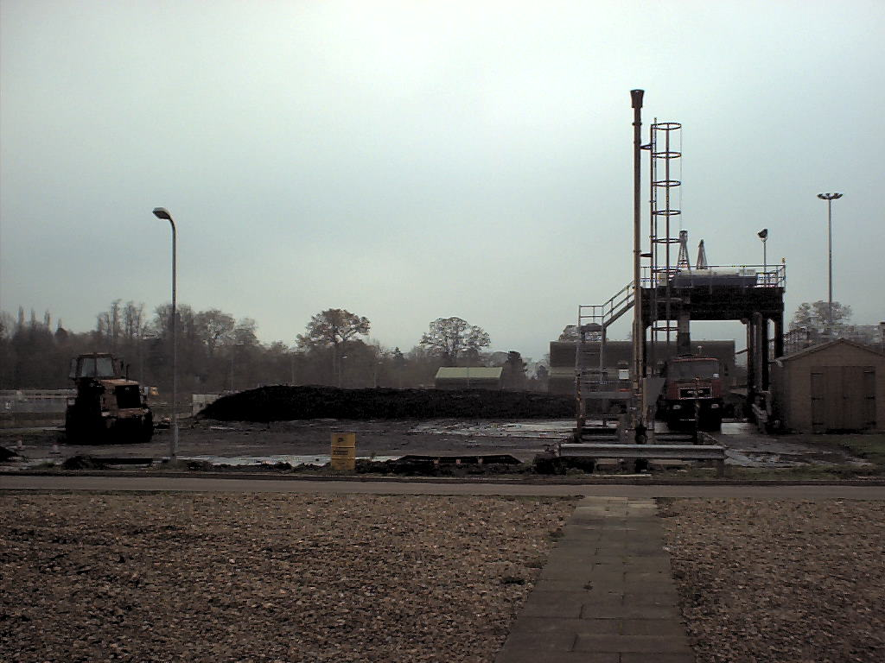

Figure 3. Digestate from sewage wastes

The volume of waste is substantially reduced by digestion and hence requires less storage space. The quality of unprocessed slurries are difficult to manage. After anaerobic digestion the quality the residue is more constant and hence easier to integrate into a fertiliser programme. The residual digest can be either applied to the land directly or separated into a liquor and a fibre.

2.1.2.1 Fibre
The fibre extracted from the residue is bulky and contains a low level of plant nutrients. It can be used to condition the soil (in some cases as a substitute for peat) and as a low grade fertiliser. The spreading of fibre requires far less power and much less specialised equipment then the spreading of unprocessed slurries. The decision may be made to further digest the fibre aerobically, prior to use or sale.

2.1.2.1 Liquor
The liquor contains a low-level but diverse range of nutrients. Liquor can be used as a liquid fertiliser as part of a crop nutrient management plan with applications of inorganic fertilisers adjusted to take account of the nutrient content of the organic fertiliser.

2.2 Nutrient Retention
Virtually all animal wastes are spread on the land in some form or other. Undigested material used as fertiliser suffers from the fact that much of the is either lost (evaporation and leaching) or is unusable by the plants. Anaerobic digestion is able to increase the amount of nitrogen present as ammonia and hence make the nitrogen more available to the plants.

2.3 Pollution Control
The intensification of agriculture following rapid population growth worldwide has lead to increased urban and agricultural wastes.

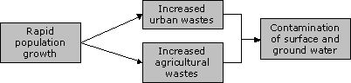

Figure 4. Environmental impact of population growth

Raw sewage and agricultural wastes represent a considerable pollution hazard. Organic matter is polluting because the bacteria that break it down absorb oxygen from the water in which it is present. In extreme cases so much oxygen is removed that aerobic life ceases and the water becomes ‘dead’. Fish kills are an all too common result of contamination of this type.

Anaerobic digestion reduces the biological oxygen demand (BOD) and chemical oxygen demand (COD) of effluents and therefore decreases the potential dangers. Anaerobic digestion offers a distinct advantage over aerobic processes in terms of pollution control as it does not require expensive oxygenation.

Another pollution concern is methane, a major greenhouse gas if allowed to escape to the atmosphere. An effective anaerobic digestion scheme will therefore maximise methane generation but not allow any to escape to the atmosphere.

2.4 Pathogen Removal
Many materials treated by anaerobic digestion may contain certain organisms potentially pathogenic for plants, animals and man. Bacteria such as Salmonella and Brucella and parasites including tapeworm are potentially present in the untreated waste. Raw sludges spread on land may introduce pathogens causing infection in farm animals or crops, run-off into water courses may result in human exposure. One potential advantage of anaerobic digestion is the removal of such organisms.

Two types of anaerobic digestion process can be identified:
- Mesophilic Digestion: The digester is heated to 30-35°C and the feedstock remains in the digester for 15-30 days. Mesophilic digestion process tends to be more robust than the thermophilic process but produces less biogas.
- Thermophilic Digestion: The digester is heated to 55°C and the residence time is typically 12-14 days. Thermophilic digestion offers higher methane production and leads to greater pathogen removal than mesophilic digestion.

It is evident that both these processes lead to a reduction in pathogen populations but pasteurisation (heat treatment at 700°C for 30 minutes) is necessary to ensure complete annihilation. Care must therefore be taken with the process residues, with the exact precautions depending on the nature of the initial feedstock.
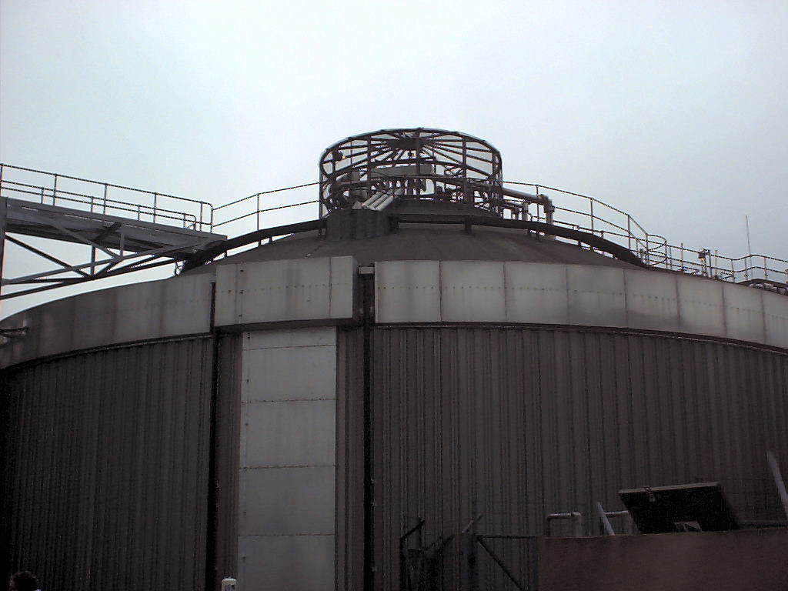

Figure 4. Sewage Waste anaerobic digester

In general the long-retention times and elevated temperatures used in anaerobic digesters lead to considerable pathogen reduction. Even raw slurry loses most of its pathogens after a few weeks on land and anaerobic digestion therefore reduces the time taken to allow the soil to reduce the pathogens to safe levels.

2.5 Odour Reduction
A well known drawback of the spreading of raw slurries on land is the unpleasant smell. The smells from decomposing faecal wastes are usually created by the release of compounds such as ammonia, volatile organic acids, and sulphides. Anaerobic digestion can reduce odour nuisance during land-spreading by up to 80%.

2.6 Weed Seed Elimination
Anaerobic digestion removes virtually all known weed seeds. Digested slurry therefore provides organic fertilisation with minimal risk of weed spread, reducing the need for costly herbicides.

2.7 Scalable Technology
Anaerobic digestion can be performed on many scales from small onsite agricultural projects to large municipal waste disposal facilities. The technology has no ‘critical mass’ and therefore is more accessible to developing countries where the production of even a relatively small amount of biogas can benefit local communities hugely.

2.8 Developed technology
During the oil crisis of the 1970s there was a surge in interest in anaerobic digestion as a potential renewable energy source. Unfortunately knowledge of anaerobic digestion was not as widespread as builders and many projects failed. China, India and Thailand reported 50% failure rates while US digesters had failures approaching 80% [8].

The prospects for anaerobic digestion today are considerably better because of the large amount of experience gained in several European countries such as Denmark, Germany, Austria and Sweden. Anaerobic digestion has also become more established in the processing of municipal waste making further uptake more viable.
An important technological advance in anaerobic digestion has been the development of methods to concentrate the methanogenic biomass in the reactor. This has been achieved by two main techniques [10]:
- Autoflocculation and gravity settling: Providing conditions which enhance the natural tendency of biomass to form aggregates (flocs) which are large enough to be separated from waste water by settling. This concept is realised in the UASB (Upflow Anaerobic Sludge Blanket) reactor.
- Immobilisation: Providing surfaces to which bacteria can attach themselves in films. The surfaces are retained in the reactor and hence so are the bacteria. This is the principle behind the anaerobic filter.
These methods reduce retention times which would otherwise be limited by the doubling time of the slowest growing bacteria (the methanogens). Interspecies transfer, essential for providing favourable thermodynamics is also aided. The methods are primarily of use in treating wastes where the majority of the organic content is in soluble form. They are therefore most often employed to deal with industrial rather than municipal and agricultural wastes.

2.9 Economic Benefits
Power and heat produced using biogas substantially reduce the energy costs of the facilities at which they are installed. This has considerable economic benefits and allows the digesters to in effect pay for themselves. If the energy (electricity or heat) produced exceeds the internal demand it can be sold off generating revenue.

Co-operative agricultural digesters can be a source of employment contributing to rural regeneration. A 1MW plant can create 2 to 5 jobs onsite, depending on the process used [11].

Industry is normally charged according to the COD content and volume of its waste. Anaerobic digestion offers an effective method of reducing the COD content, producing substantial economic savings.

2.10 Domestic Waste Recycling
Treatment of domestic organic wastes with anaerobic digestion reduces the flow of material to landfills which are in effect un-optimised anaerobic digesters. ‘Landfill gas’ containing methane is often collected at sites and used to generate electricity. Processing of wastes with purpose built digesters offers a much more efficient use of the waste material, and more controlled and effective stabilisation.

2.11 Developing Country Applications
Anaerobic digestion has proved a very successful source of energy for remote, off-grid, rural areas in some developing countries. China has implemented an extremely effective biogas scheme which has resulted in the installation of millions of systems throughout the country[12]. In rural areas a small digester connected with a latrine and pigsty was recommended and popularised. The programme initially gave financial incentives to promote uptake, but is now sufficiently mature to be self-sustaining and subsidies to all but the poorest farmers have been eliminated. In isolated areas the government continues to support loan systems to help farmers overcome the initial capital cost.

The primary domestic uses of biogas are cooking and lighting. Specially designed stoves must be used as biogas has different properties from other commonly used gases (propane, butane etc.) and is only available at low pressure. Lighting is normally provided by means of a gas mantle [13].

2.12 Fuel based renewable / Peak Generation
Unlike other renewables such as wind and solar, anaerobic digestion produces energy in the form of a fuel.

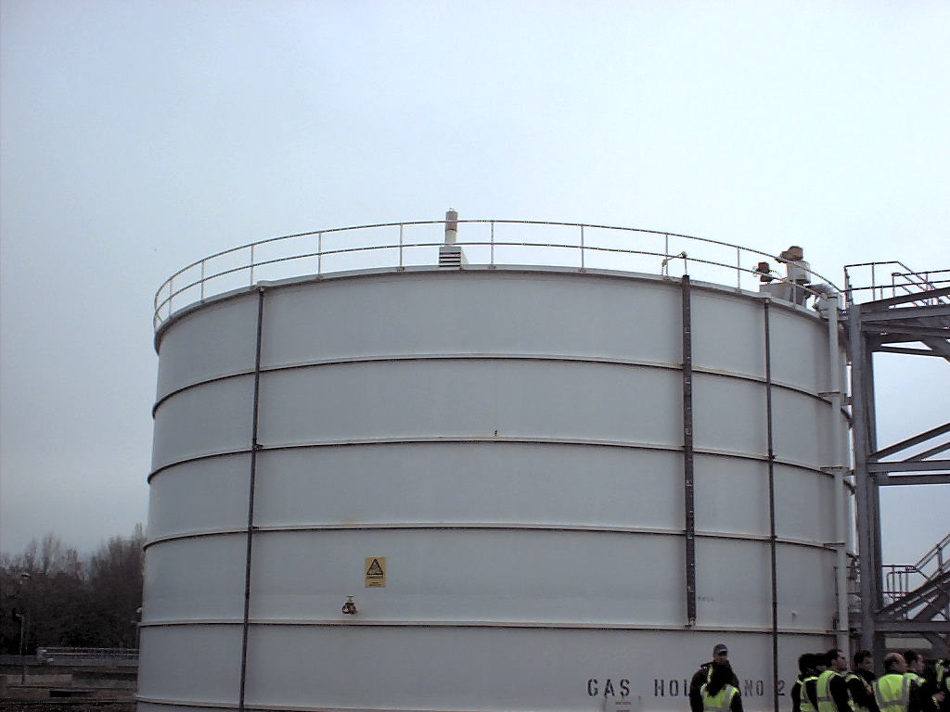

Figure 5. Gas storage tank

Therefore the option exists to store the biogas and increase electricity production during peak demand times. In this way the usefulness and profitability of the whole process is maximised.

3. Disadvantages

Unfortunately implementation of the anaerobic digestion process has substantial drawbacks, largely responsible for its limited uptake.

3.1 Environmental Sensitivities
The anaerobic digestion process can be viewed as inefficient in that most of the energy of the organic material ends up in the methane contained in the biogas. The anaerobic bacteria in comparison to their aerobic counterparts are very bad at extracting energy from the organic feed. Only about 5-10% of the energy transferred from the complex organics to methane is available for the bacteria to use for growing, compared to 50% for the equivalent aerobic process [14]. As a result anaerobic bacteria tend to be slower growing and more sensitive to changes in conditions. Maintaining a suitable environment in the digester is therefore essential for successful operation.

Several parameters need to be tightly controlled in order to achieve optimum performance:
- pH: Anaerobic bacteria are strongly inhibited unless the digester pH is maintained at neutral.
- Temperature: Mesophilic / Thermophilic temperatures must be maintained or biogas production will be reduced.
- Salts: Bacteria require minimum amounts of salts for optimum growth. However if salts are allowed to accumulated beyond requirements digestion is inhibited.
- Alkalinity: Acids are produced as intermediates during the digestion process. If sufficient alkalinity is not present this will cause an increase in pH inhibiting digestion.
- A variety of other materials can also prove toxic to the anaerobes including heavy metals, ammonia and antibiotics. Ammonia toxicity is a major concern in the digestion of livestock manure [15].
All of these contribute to the fact that anaerobic digestion requires more stringent process controls than the more robust aerobic treatment.

3.2 Fluctuating Loads
The COD of the waste feed must be strictly managed if digester performance is not to be adversely affected. Anaerobic digestion is performed by a synergistic consortium of micro-organisms and the pH sensitivity described in the previous section is in fact due primarily to one member group of bacteria, the methanogens.

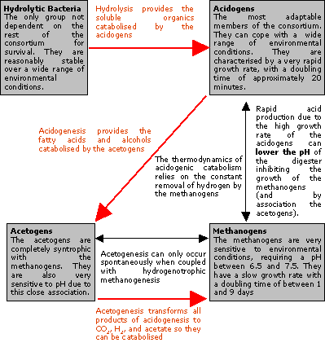

Figure 6. Interdependence of anaerobes
Fig. 6 illustrates the interdependencies of the facultative anaerobic micro-organisms. A delicate balance exists between the different sub-groups and steady state conditions are achieved over a period of months. The process can easily be upset if the COD of the influent is not carefully maintained at a constant level.

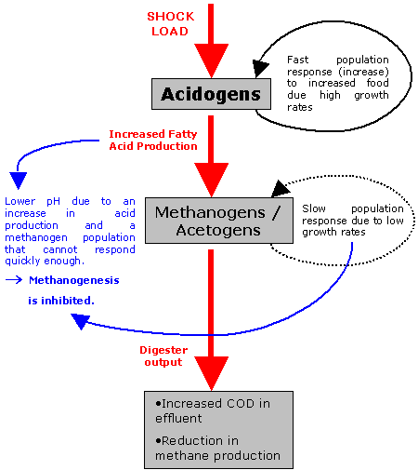

Figure. 7 Inhibition caused by fluctuating organic load

Fig. 7 illustrates what happens is the digester is subject to a sudden increase in organic load (shock). The slow growing methanogens are not able to cope with the increased acid production caused by an increase in the organic load. The inhibition of the methanogens then in turn adversely effects the acidogens and the acetogens. The delicate balance has been disturbed causing a reduction in performance (COD removal and biogas production) and in extreme cases a complete breakdown of the process (souring).

3.3 Comparatively Low COD Removal
Anaerobic digestion will generally achieve organic pollution reduction in the region of 85-90% [16]. A second (usually aerobic) step is therefore often needed to attain satisfactory removal of COD. Local authorities will usually charge industry according to the volume and COD of their waste. Manufacturers may therefore decide to forego any secondary treatment and incur the additional charges.

3.4 Capital Investment
The high initial costs required to develop an aerobic digester are often the biggest obstacle to their implementation. From a large industrial project to a small on-farm digester the relative size of the capital expenditure is potentially prohibitive.

3.5 Required Expertise
The delicate nature of anaerobic digestion discussed in Secs. 3.1-3.2 mean that the process cannot be treated as a ‘black-box’. A thorough understanding of the subtleties of the process is required for successful operation. In developing regions the required expertise may simply not be available. For applications in developed countries the cost of employing people with the necessary skills adds to both the initial capital and running costs.

3.6 Hydrogen Sulphide Production
The presence of sulphur in waste feeds leads to the production of hydrogen sulphide during digestion. The H₂S will then form a component of the generated biogas. Hydrogen sulphide is extremely corrosive and its presence requires the purchase of more robust and therefore expense generators.

3.8 Persistence of Heavy Metals
Another problem with anaerobic digestion occurs due to the fact that the feedstock may contain heavy metals or persistent organic pollutants (POPs). Heavy metals cannot be destroyed by digestion and thus the only way they can be controlled is to ensure that the feedstock is as clean as possible [17].

3.8 Economic Viability
Anaerobic digestion is not viable purely as a source of renewable energy. All other benefits of the process (stabilisation, optimum inorganic nutrient recycle, savings on synthetic fertilisers, sale of liquid fertiliser and compost) must be fully exploited in order for it to be economic.

4. CONCLUSIONS

The advantages and disadvantages of the anaerobic digestion have been assessed. The process is primary of importance in terms of waste stabilisation and pollution control but its many fringe benefits improve its viability. The methane produced by anaerobic digestion is an important renewable energy source but does not justify implementation solely for this purpose. The inherent complexities and high start-up costs of anaerobic digestion continue to hamper its development.

5. ACKNOWEDGEMENTS
I would like to thank Prof. Andrew Wheatley for all his advice on the subject in question. I would also like to thank Severn Trent Water Ltd. for the opportunity to visit their biogas facility which is featured in the photographs in this report. Great appreciation is owed to David Longden who took the pictures.

6. REFERENCES

[1] Thames Waste Management Limited web-page, http://www.twm.co.uk/anaerobic_digestion.html
(Accessed November 2002)
[2] “Sewage sludge production in the EU”, http://www.scientecmatrix.com/seghers/tecma/scientecmatrix.nsf/_/B8516D2FE007E0E0C1256B5D00394D37 (Accessed November 2002).
[3] British Biogen, “AD Good Practice Guidelines”, http://www.britishbiogen.co.uk/gpg/adgpg/adgpg.pdf
(Accessed 12 November 2002)
[4] T. Mahony, V. O’Flaherty, E. Colleran, E. Killilea, S. Scott, J. Curtis , “Feasibility study for centralised anaerobic digestion for treatment of various wastes and wastewaters in sensitive catchment areas (2002)”, http://www.epa.ie/r_d/downloads/publications/94%20to%2099/report16/Ch1_5.pdf
[5] I.D. Cowley, D.A.J Wase, “Anaerobic Digestion of Farm Wastes; a Review – Part 1”, Process Biochemistry Aug/Sept 1981, p 28-33.
[6] D. L. Klass, “Biomass for renewable energy, fuels, and chemicals”, San Diego, Calif. ; London : Academic Press, (1998).
[7] C. da Costa Gomez, ”Biogas - A Reliable Income for German Farmers ?”, http://www.biogas.org/english/frame1.html
[8] D.A. Stafford, ”Methane production from waste organic matter”, West Palm Beach, Fla : CRC Press, (1979).
[9] Lusk, P. and Moser, M. (1996). “Anaerobic Digestion – Yesterday, Today and Tomorrow.” Ninth European Bioenergy Conference; June 24-27, 1996, Copenhagen, Denmark. UK: Pergamon Press; pp. 284-289.
[10] I.J. Callander, J.P. Barford, “Recent Advances in Anaerobic Digestion Technology”, Process Biochemistry August 1983.
[11] “AD – NETT- the Anaerobic Digestion Network”, http://www.ad-nett.org/, (Accessed December 2002).
[12] Intermediate Technology Development Group, IT Consultants, IT Power and ITDG Latin America, “Sustainable Energy for Poverty Reduction: an Action Plan”, http://www.itdg.org/html/advocacy/docs/itdg-greenpeace-study.pdf (Accessed November 2002)
[13] U. Marchaim, “Biogas processes for sustainable development”, http://www.fao.org/docrep/t0541e/T0541E00.htm#Contents (Accessed December 2002).
[14] N.E.H. Feilden, “The Theory and Practice of Anaerobic Digestion Reactor Design”, Process Biochemistry October 1982.
[15] C. D. Fulhage, D. Sievers and J. R. Fischer, “Generating Methane Gas From Manure”, http://muextension.missouri.edu/explore/agguides/agengin/g01881.htm
[16] “Anaerobic Digestion in Wastewater Treatment”, http://www.scientecmatrix.com/seghers/tecma/scientecmatrix.nsf/vFeaturePDF/0011/$file/AnaerobicDigestionInWasteWaterTreatment.pdf (Accessed December 2002)
[17] A. Wellinger, T. Jaatinen, P. Lusk,M. Perkin, E. Pfieffer, S. Tatdrup, P. Wheeler, “Biogas and More!”, http://websrv5.sdu.dk/bio/free.htm (Accessed December 2002).

