#### PChem Experiment No. 5

#### Kinetics of the hydrolysis of methyl salicylate monitored by spectrophotometry

#### 1. Aims (max. 150 words)

This experiment aims to determine the pseudo first order rate constant for the reaction of methyl salicylate in 10% aqueous KOH. Having determined the pseudo first order rate constant, the bimolecular rate constant for the reaction of OH- with methyl salicylate is to be calculated.

#### 2. Introduction (max. 1000 words)

The reaction being monitored in this experiment is the hydrolysis of the ester phenolic ester methyl salicylate using the base KOH. This reaction has the characteristic equation:

$${}_{}^{-}OC_{6}H_{4}COOMe+OH^{-}\overset{→}{←} {}_{}^{-}OC_{6}H_{4}COO^{-}+ MeOH$$

The gradual conversion of the phenolic ester methyl salicylate ($HOC_{6}H_{4}COOMe$) to the sodium salt (${}_{}^{-}OC_{6}H_{4}COO^{-}$) takes a number of minutes to reach equilibrium.

The rate for the reaction is given by:

$$Rate=k_{2}\left[Ester\right][OH^{-}]$$

Where k2 can be taken as the second order rate constant and the reaction equation is second order.

However under the conditions in this experiment the hydroxide ion is present in large excess. The amount consumed is negligible so the effective value for [OH-] is a constant. Hence the apparent, or pseudo-rate constant, $K_{1}^{a}$ can be taken as follows:

$$K_{1}^{a}=k_{2}[OH^{-}]$$

Resulting in the pseudo-rate equation to be given by:

$$Rate=K_{1}^{a}\left[Ester\right]$$

.

Photometric analysis of the sample can be used to identify the concentration of constituents of the reaction solution. The absorbance for incident light on the solution will be periodically assessed using a computer controlled UV spectrometer.

The absorbance of an incident monochromatic light beam by a constituent (Ax) can be related to the concentration of the constituent (cx) according to the relation:

$$A_{x}=ε_{x}c_{x}l$$

Where $ε_{x}$ the molar absorptivity of the constituent in question and l is is the path length through the medium.

For a mixture of species the relation can be used as:

$$A_{total}=A_{ester}+A_{salt}$$

We then have the relation:

$$\frac{X_{0}}{X_{t}}=\frac{A_{0}-A_{t}}{A_{t}-A_{∞}}$$

Where $X_{0}$ and $X_{t}$ are the concentrations a times 0 and t, and $A_{0}, A_{t}$ and $A_{∞}$ are the absorbencies at times 0, t and $∞$.

For first-order kinetics, the following relation holds:

$$\ln\left(\frac{X_{0}}{X_{t}}\right)=k_{exp}t$$

Where $k_{exp}$ is the rate constant (for this experiment, the pseudo-first order constant).

By combining the previous equations the relation

$$\ln\left(\frac{A_{0}-A_{t}}{A_{t}-A_{∞}}\right)=k_{exp}t$$

Is true.

Therefore, by plotting ln($A_{t}-A_{∞}$) as function of t, the curve should have a slope equal to - $k_{exp}t$.

By evaluating the pseudo-first order rate constant for the reaction, $k_{exp}$, the actual second order rate constant can be calculated as follows:

$$k=\frac{k_{exp}}{[OH^{-}]}$$

For this calculation, $[OH^{-}]$ can be taken to be the initial concentration of hydroxide ion in the solution, as the change to this value is negligible between initial conditions and final equilibrium.

#### 3. Experimental Procedure (no max.)

A solution of methyl salicylate was prepared by addition of the ester to deionised water and shaking. The solution was filtered to remove droplets on the ester. 0.6cm3 of the solution was added to 9.4cm3 of 10% aqueous KOH. The molarity of KOH in the resultant solution was calculated to be 1.68moles L-1. Immediately on addition of the 10% KOH solution, a stop-clock was started. Two cells were inserted into the UV spectrometer, a reference cell containing deionised water and a cell containing the reacting solution. When the machine made the first scan, the time on the stop-watch was noted and recorded as 332seconds.This was added to all subsequent values for time. The spectrometer completed scans of the solutions every 5 minutes for half an hour. For each scan, the absorbance of the solution at a wavelength of 332nm was noted from the graph and recorded. An Isosbestic point was observed at approximately a wavelength of 310nm. A final scan was taken 60 minutes after the initial scan, and again the absorbance at 332nm was recorded.

The 60 minute scan was used to estimate the value of $A_{∞}$ by subtracting 0.05 units from the absorbance at 332nm for this scan.

#### 4. Results (no max.)

The absorbance curves with wavelength were plotted at intervals of 5 minutes and one after 60 minutes from the initial scan as follows:

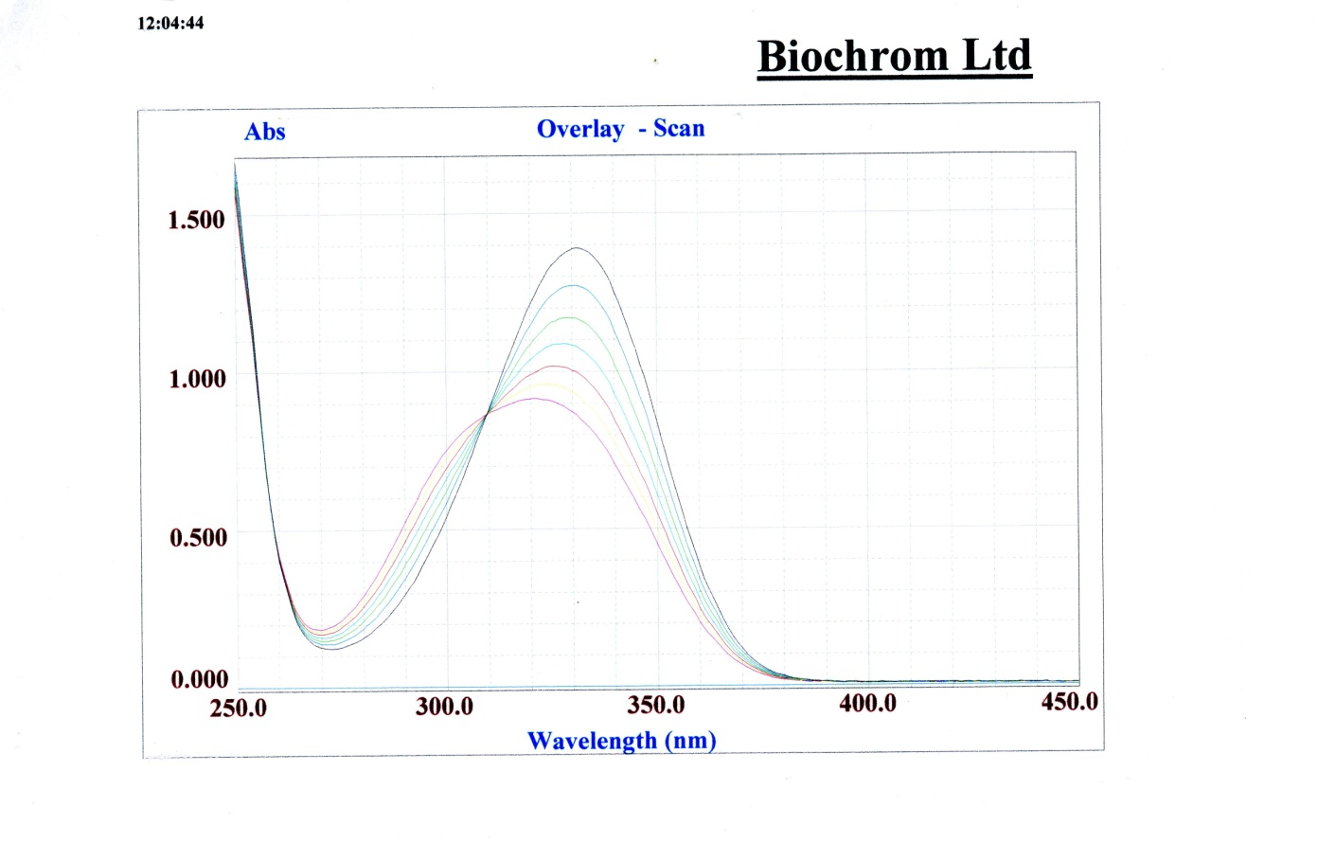

The following is a table of data attained in the experiment:

|  |  |  |  |  |
| --- | --- | --- | --- | --- |
| Time | A(t) | A(t)-A(infinity) | ln(A(t)) | ln(A(t)-A(infinity)) |
| 332 | 1.4 | 0.91 | 0.336472 | -0.094310679 |
| 632 | 1.254 | 0.764 | 0.226338 | -0.26918749 |
| 932 | 1.161 | 0.671 | 0.149282 | -0.398986142 |
| 1232 | 1.068 | 0.578 | 0.065788 | -0.54818141 |
| 1532 | 0.984 | 0.494 | -0.01613 | -0.705219762 |
| 1832 | 0.921 | 0.431 | -0.0823 | -0.841647189 |
| 2132 | 0.852 | 0.362 | -0.16017 | -1.016111067 |

Ln($A_{t}-A_{∞}$) was plotted as function of t, as follows:

The previously calculated value for the initial concentration of hydroxide ions in the solution was used to calculate the true second order rate as follows:

$$k=\frac{k_{exp}}{[OH^{-}]}=\frac{0.0005}{1.68}=2.9762x{10}^{-4}L { mol}^{-1}s^{-1}$$

#### 5. Discussion and Conclusions

The logarithmic plot of $(A_{t}-A_{∞})$ with time yielded a linear correlation with a R2 value of >0.99. This was satisfactory for the purposes of the experiment. However, the plot equation of the plot contained a constant of 0.0651 which did not correlate to the equation derived for the experiment. This could be contributed to a number of errors, including inaccuracy in the value of time taken between preparation of the solution and scanning with the spectrometer, which was recorded on a stopwatch and subject to significant human error. Alternatively, this discrepancy could be contributed to inaccuracy in measurement of the absorptions at 332nm.This value was gauged by eye directly off the curve and hence also subject to human error..

#### Answer the following post-practical questions

1. Do your results show that the decay of the ester adheres to first-order kinetics?

The Decay of the signal produced by the ester molecule in solution suitably adhered to first order kinetics for the accuracy of the experiment.

2) What can you say about the relative values of the extinction coefficients of products and reactants at the isosbestic point?

#### The extinction coefficients for both products and reactants are equal at the isosbestic point. They both absorb light of that specific wavelength to the same extent when in solution, and hence the absorption at that point remains constant for the reaction progression.

#### PChem Experiment 5

#### Pre-practical questions:

1) From the expression for the rate of change of reactant X which follows nth order kinetics



Show that if the kinetics are first order, equation (6) in the manual is derived and that [X] decays exponentially.

The calculations were carried out as follows:

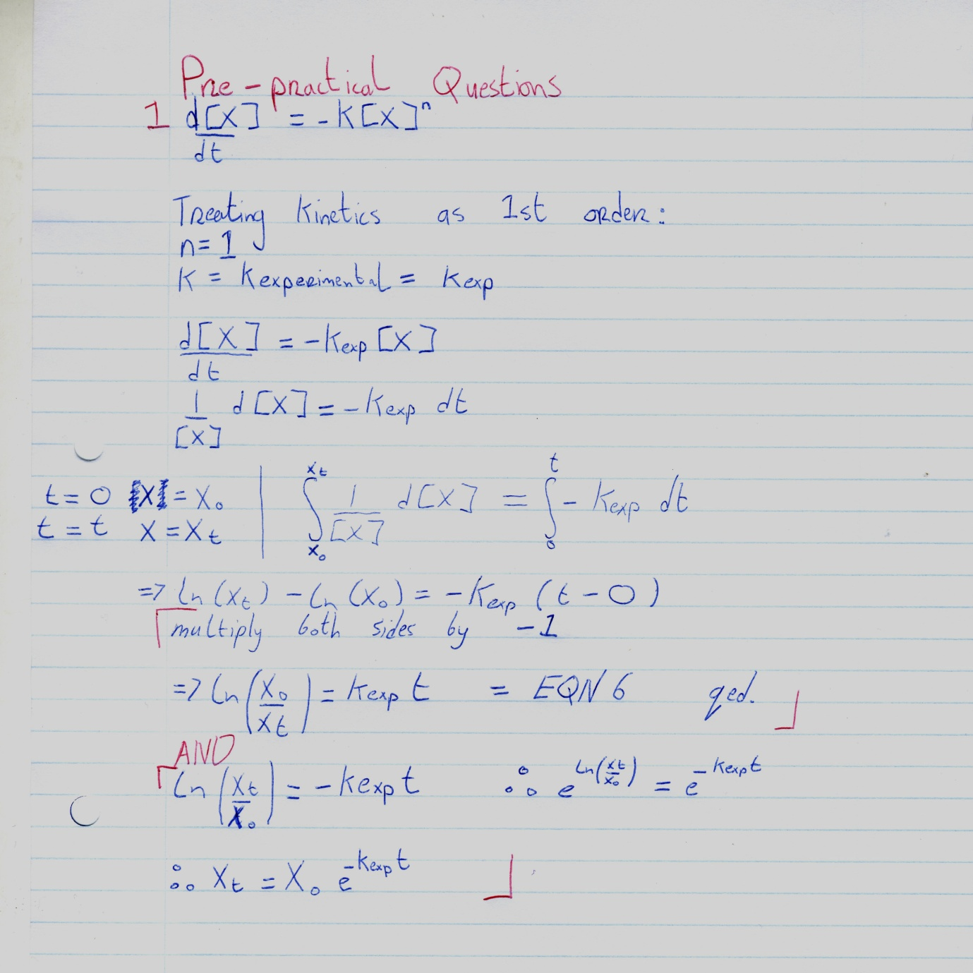

2) What is the significance of an isosbestic point?

The isosbestic point is given by the wavelength of light for which two species in solution have the same molar absorptivity, $ε_{x}$. The level of absorption at this wavelength remains with respect to time for the progression of the experiment, as because both species absorb light of that frequency equally, their relative concentrations have no bearing on absorption at the frequency in question. It was observed at roughly 310nm for the ester and the sodium salt in this experiment.

Name _ Louis Gregg_________________________________

Student Number_________10336691___________________

Date __________________11/03/2012____________________

Lab Partner’s Name: ___________________Richard Durning_______________

Demonstrator _________?_____________________